**UCS 2611 Internet Programming Lab**

**Exercise 12. Full Stack Todo Web Application using ReactJS, Node and MongoDB**

Develop a ***Todo Web Application*** that enables the user to maintain and keep track of their Todo list [CO2, K3]

Draw a diagram depicting the design flow of your project with necessary components, endpoints and collections

Application has the following:

* Front end to provide necessary requests using ReactJS
* Maintain the details in MongoDB
* Define necessary functionalities in the required components and endpoints in node server to display the Todo application like below:

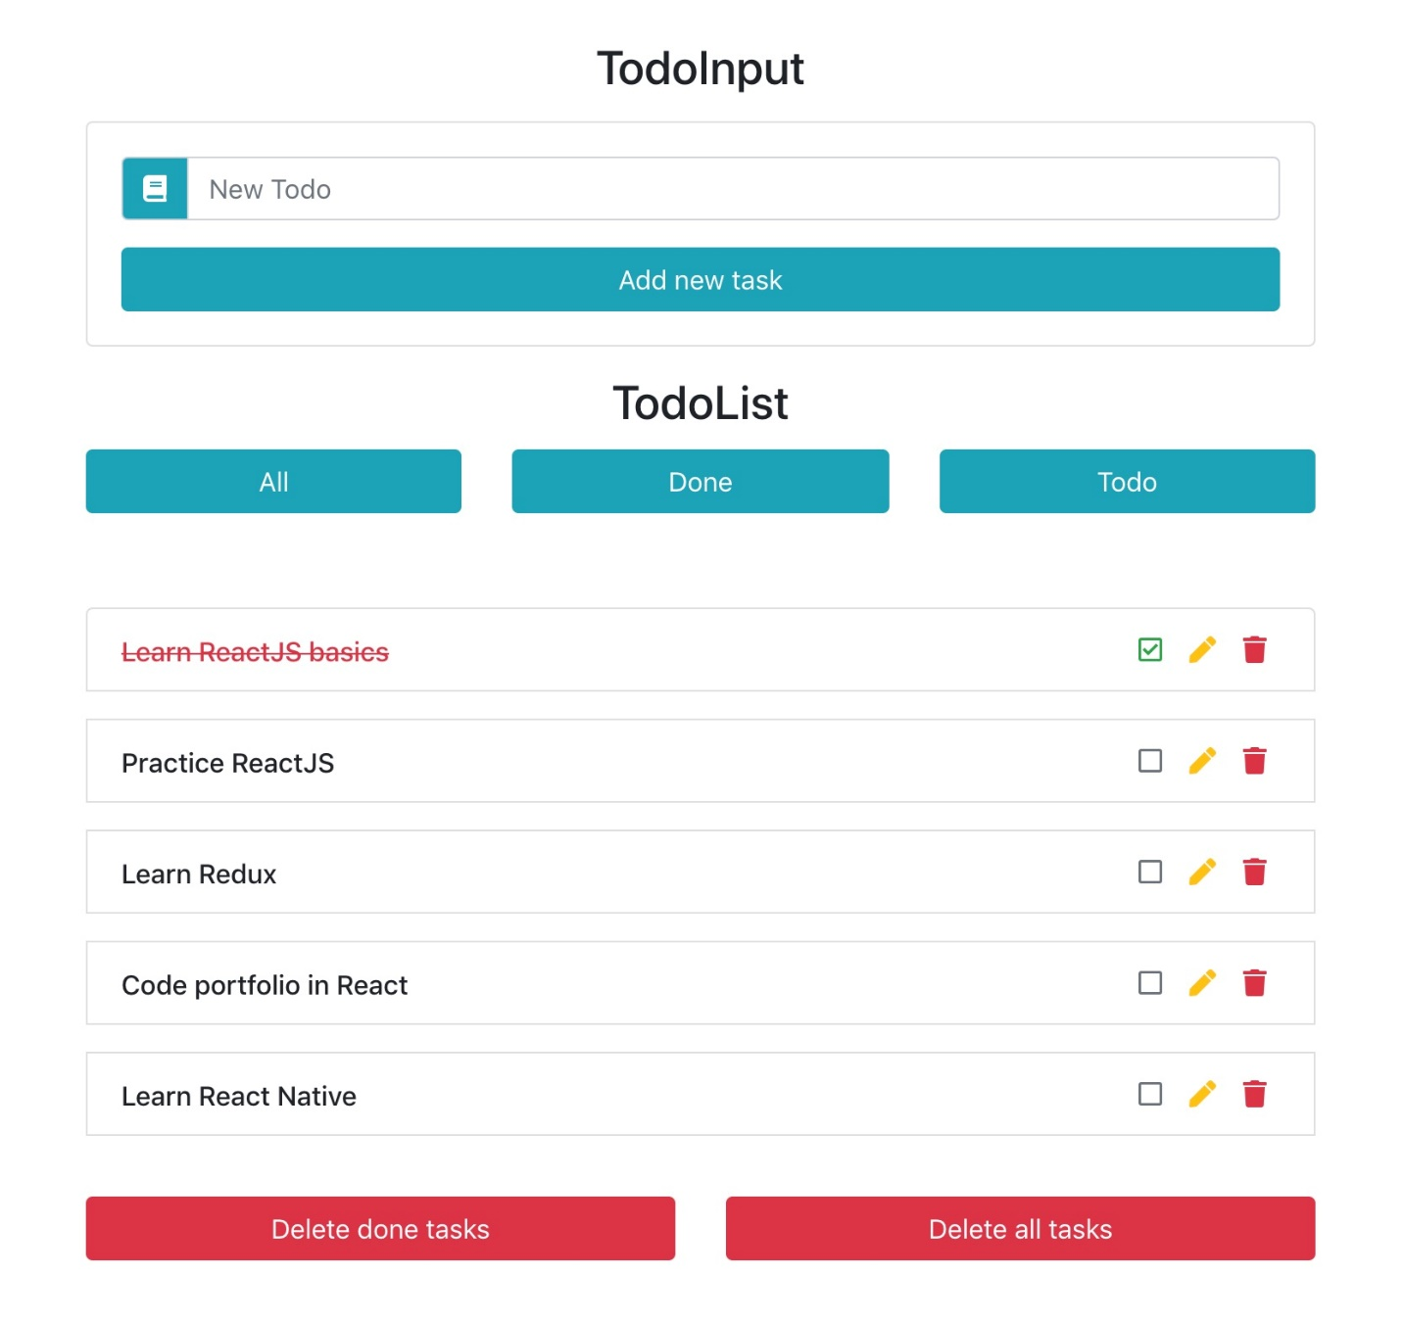

Best Practices to be followed:

1. Design before coding
2. Incremental coding
3. Usage of proper naming convention
4. Usage of Comments to the code
5. Indentation of code